Exercise 1: Setting Up Junit

**MyJUnitclass.java**

package Cognizant;

public class MyJUnitclass {

public int add(int a, int b) {

return a + b;

}

public static String ConCat(String a, String b) {

return a + b;

}

}

**AddTest.java**

package Cognizant;

import static org.junit.Assert.*;

import org.junit.Test;

public class AddTest {

@Test

public void AddTest() {

MyJUnitclass junit = new MyJUnitclass();

int result = junit.add(100, 200);

assertEquals(300, result);

}

}

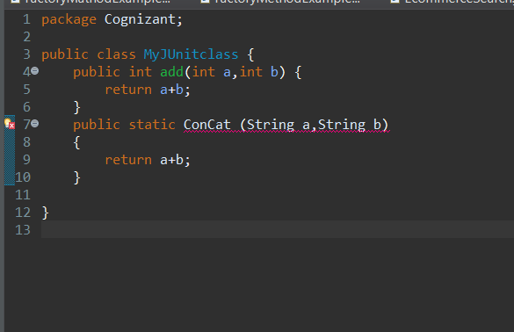

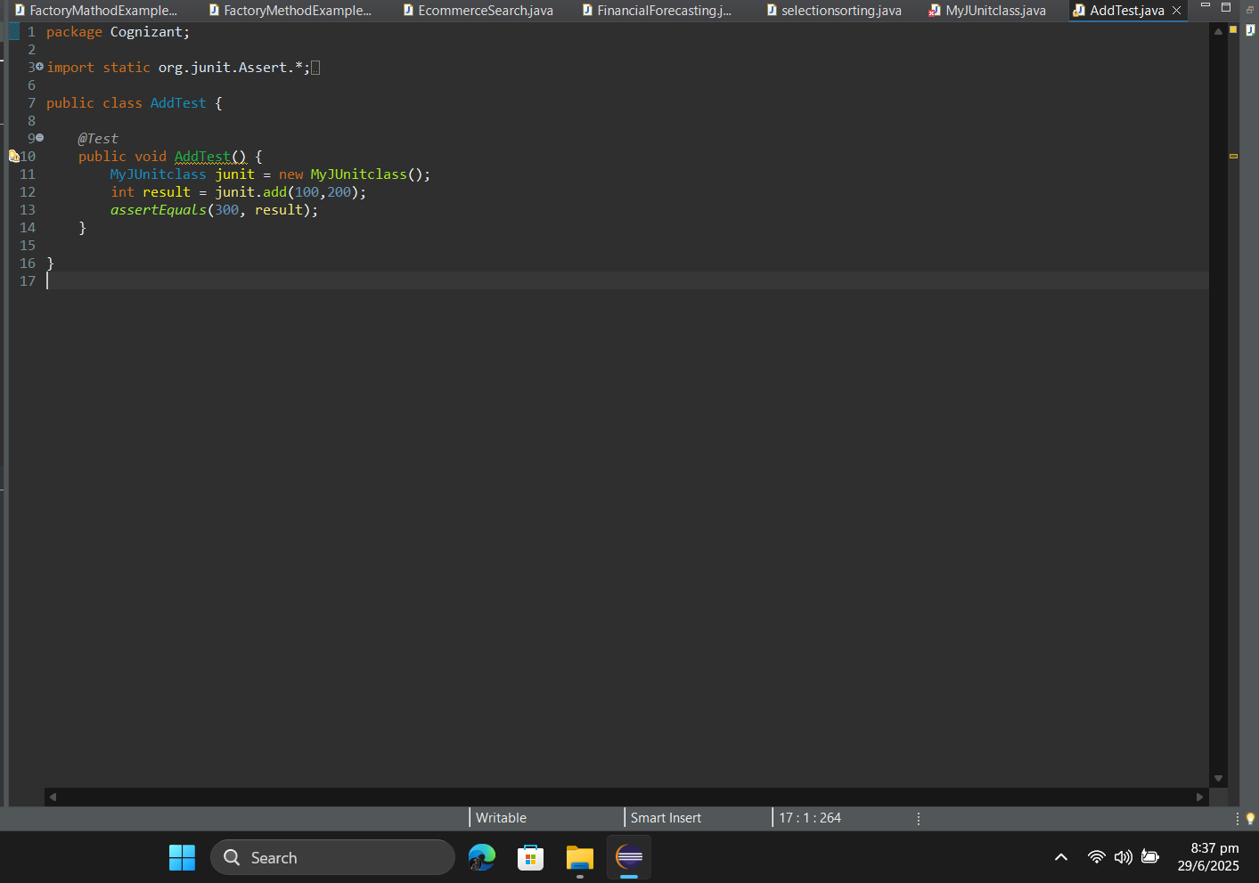



Exercise 2: Assertions in JUnit

**AssertionTestTest.java**

package Cognizant;

import static org.junit.Assert.*;

import org.junit.Test;

public class AssertionTestTest {

@Test

public void test() {

assertEquals("2 + 3 should equal 5", 5, 2 + 3);

assertTrue("5 should be greater than 3", 5 > 3);

assertFalse("5 should not be less than 3", 5 < 3);

Object obj1 = null;

assertNull("Object should be null", obj1);

Object obj2 = new Object();

assertNotNull("Object should not be null", obj2);

}

}

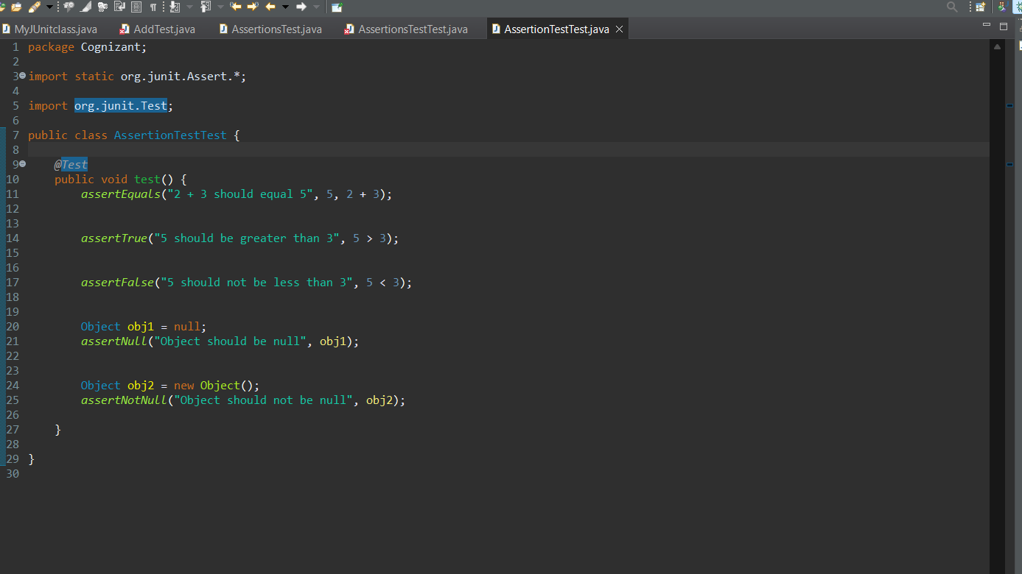

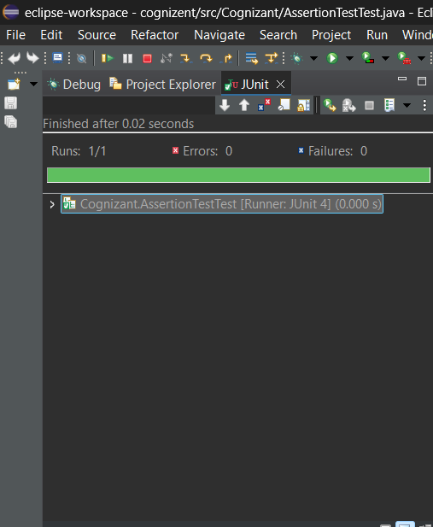

**Exercise 3: AAA Pattern, Setup and Teardown**

**Calculator.java**

package Cognizant;

public class Calculator {

public int add(int a, int b) {

return a + b;

}

public void close() {

System.out.println("Calculator closed.");

}

}

**CalculatorTest.java**

package Cognizant;

import static org.junit.Assert.*;

import org.junit.After;

import org.junit.Before;

import org.junit.Test;

public class CalculatorTest {

private Calculator calculator;

@Before

public void setUp() {

calculator = new Calculator();

System.out.println("Setup complete.");

}

@After

public void tearDown() {

calculator.close();

calculator = null;

System.out.println("Teardown complete.");

}

@Test

JUnit Assessment Solutions

public void testAddition() {

int result = calculator.add(2, 3);

assertEquals("2 + 3 should be 5", 5, result);

}

@Test

public void testAdditionWithNegativeNumbers() {

int result = calculator.add(-2, -3);

assertEquals("-2 + -3 should be -5", -5, result);

}

}

